Part C

PART D

S=0.2

S=10

S=10^5

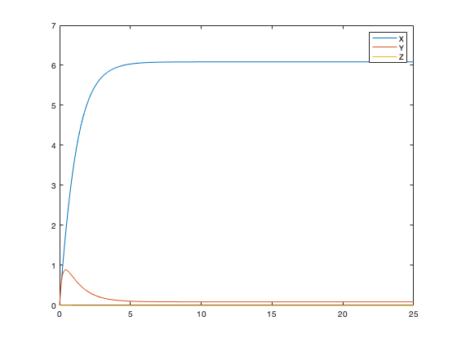

PART E

